STA. TERESA COLLEGE

Bauan, Batangas

COLLEGE DEPARTMENT

NARRATIVE REPORT ENTITLED The Advantage of quarantine in our home

In partial fulfillment of the Requirements for NSTP-CWTS 2

(Home- based Project)

Submitted by:

Lyka O. Penolbo

ACT 1

Submitted to:

Jayson A. Balayantoc

NSTP Instructor

1. **Project Title: The Advantage of quarantine in our home**

Coming up in this title is easy for me because all of us experiencing quarantine now. Quarantine is also disadvantage to many, because it has a big impact or effect in their or our daily life but for me it is also advantage for us taking NSTP course because we can help our family in every household and for us to improve our work not only in our house but only in other things.

1. **Description**

This program aims to accomplish something in home in simple task while it was quarantine and the target client of this program is my family. The duration of this program is from May 04 to May 31.

1. **Objectives**

* To help parents with simple task
* To improve movement in simple task
* To be lessen work for parents so that they can able to rest properly while their child is home.

**IV.Work Schedule or Plan of Implemention**

**A.**Make a table of the activities with the schedule or plan of implemention.

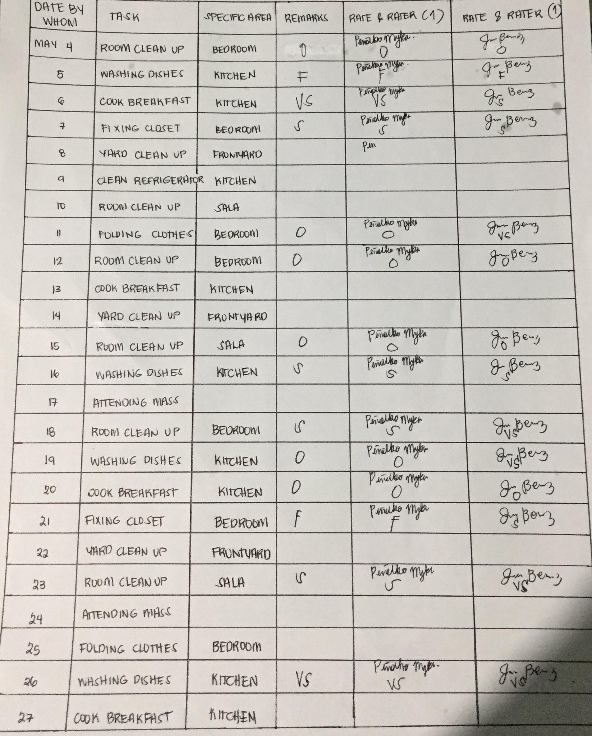

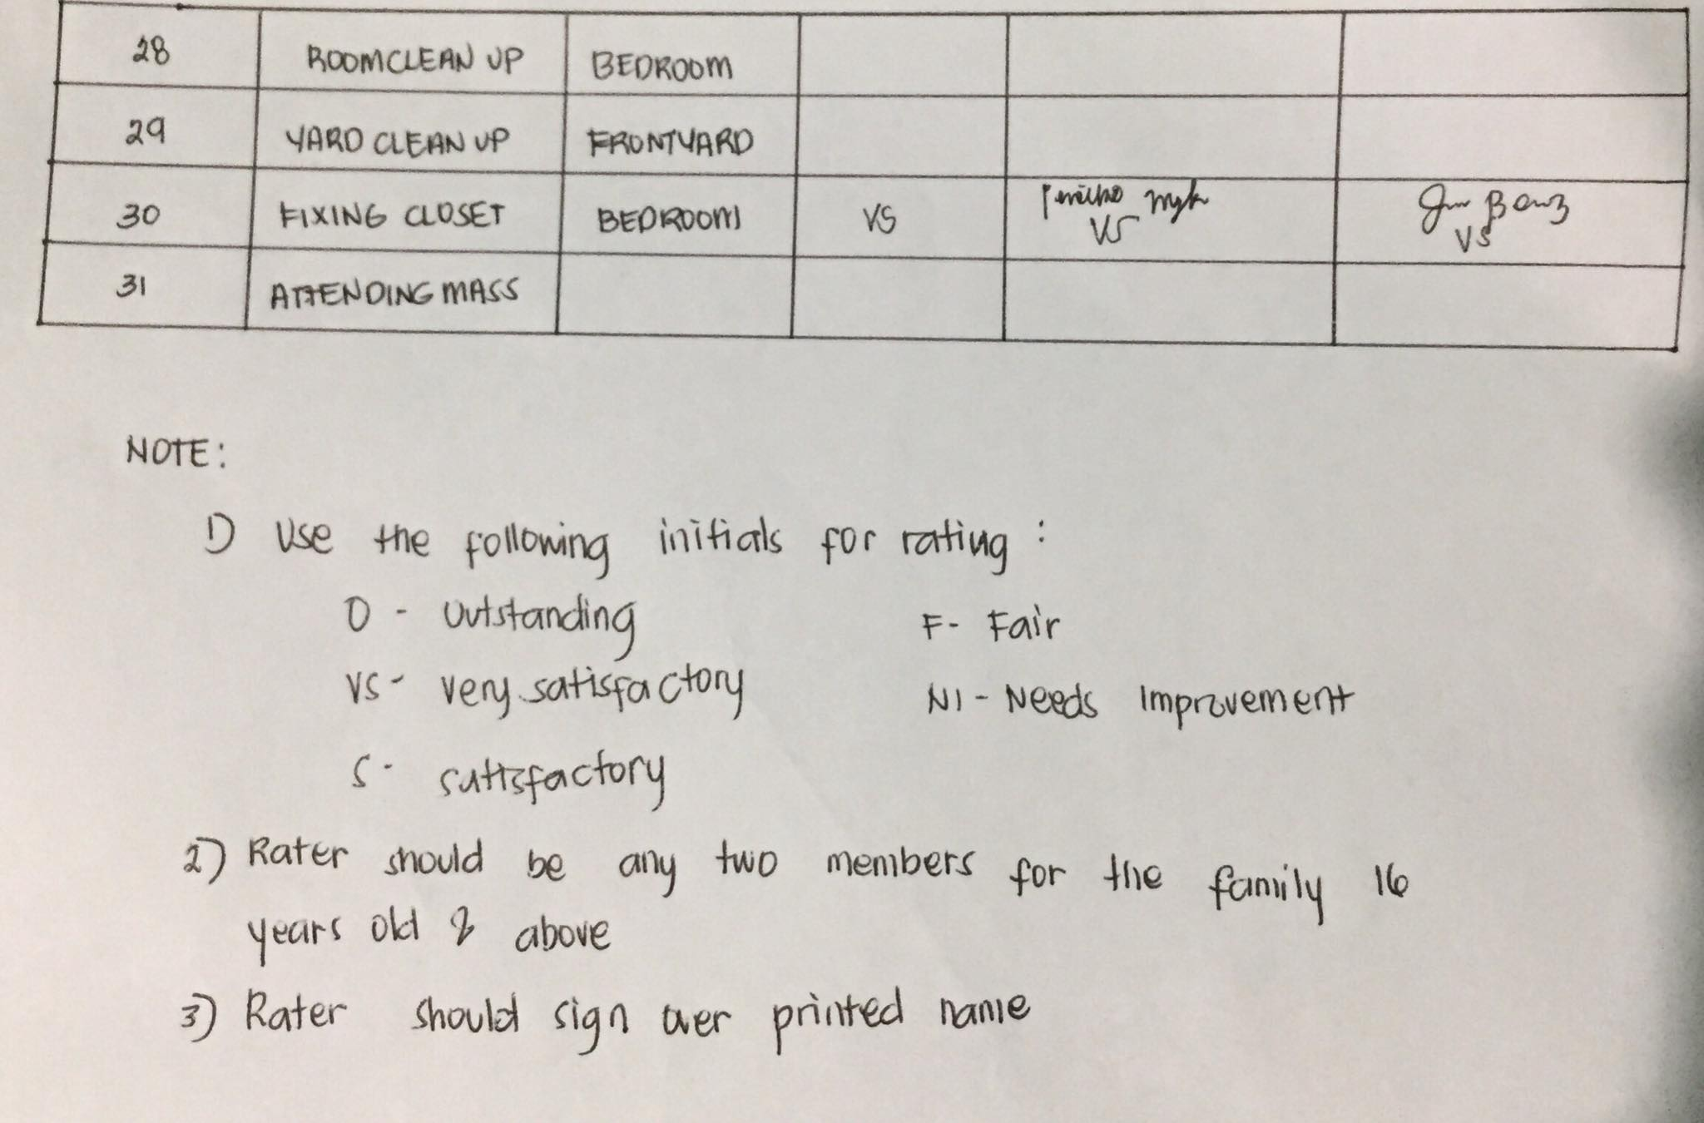

**B.**The Activities

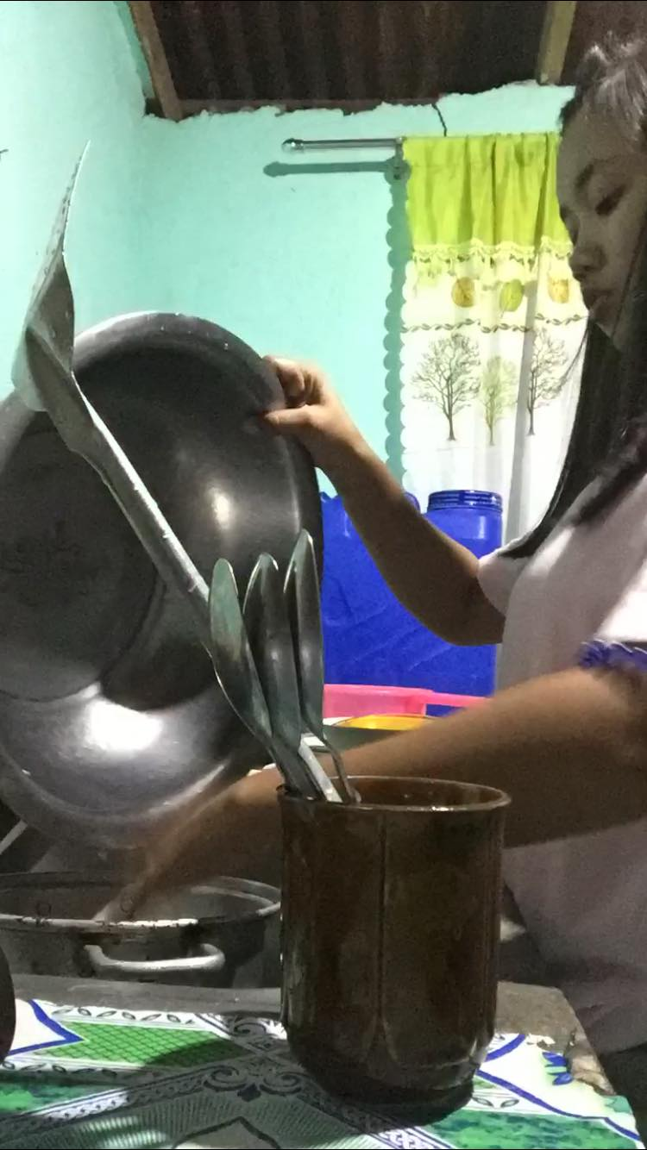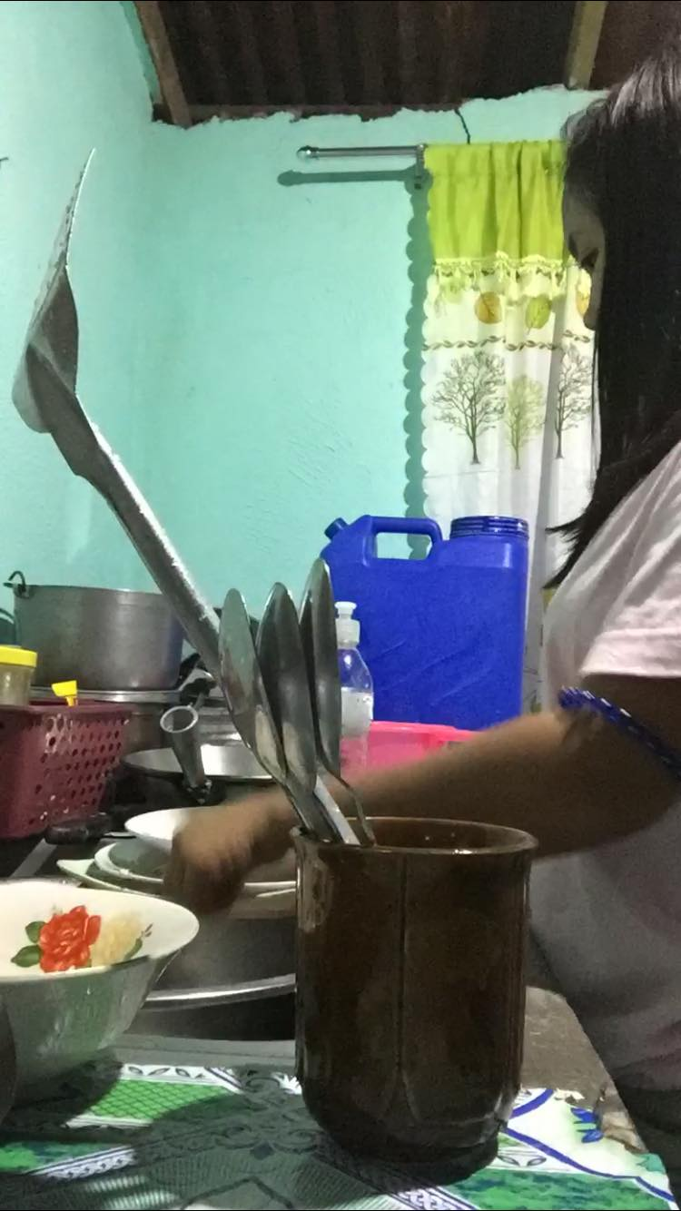

In able to accomplish my project I am supposed to do some household chores like washing dishes.

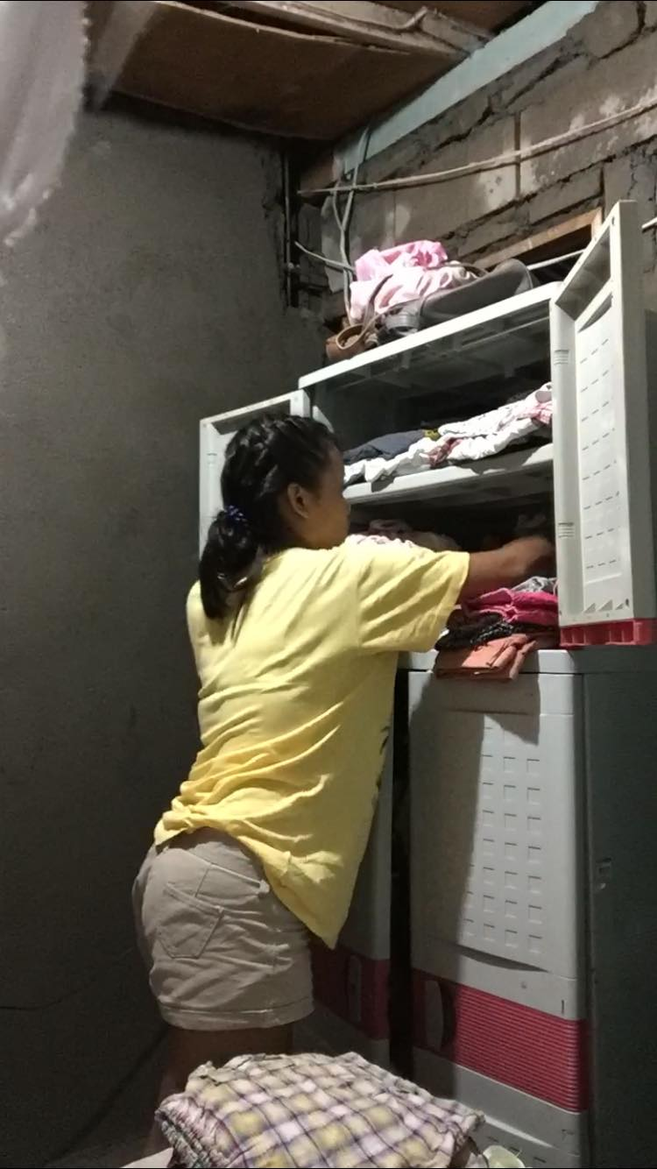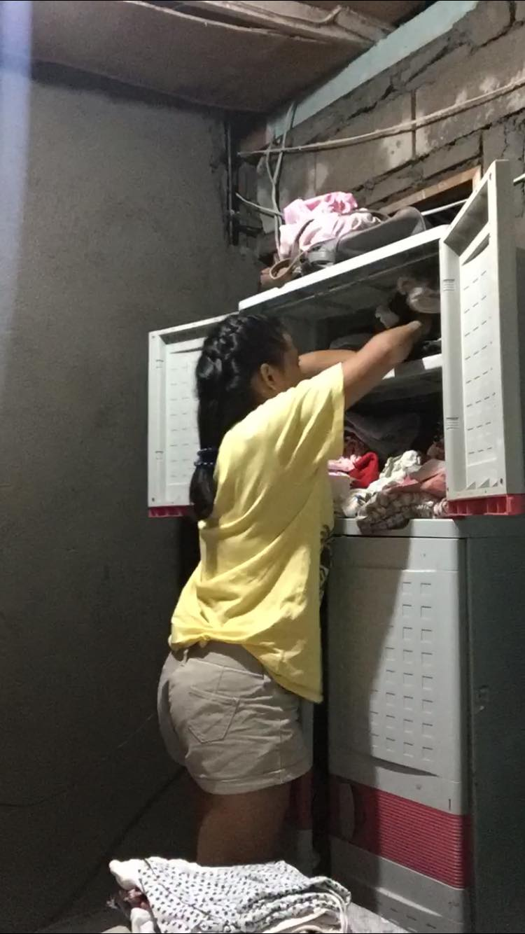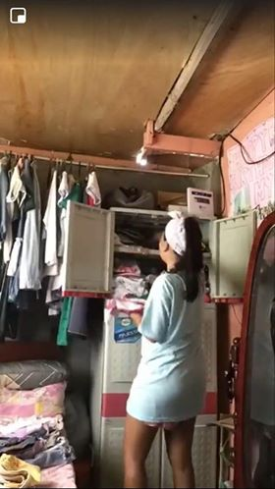

Fixing closet is also one of my task to fulfill my quarantine task.

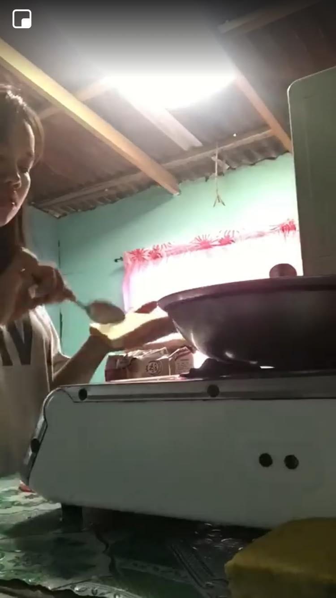

Cooking Breakfast

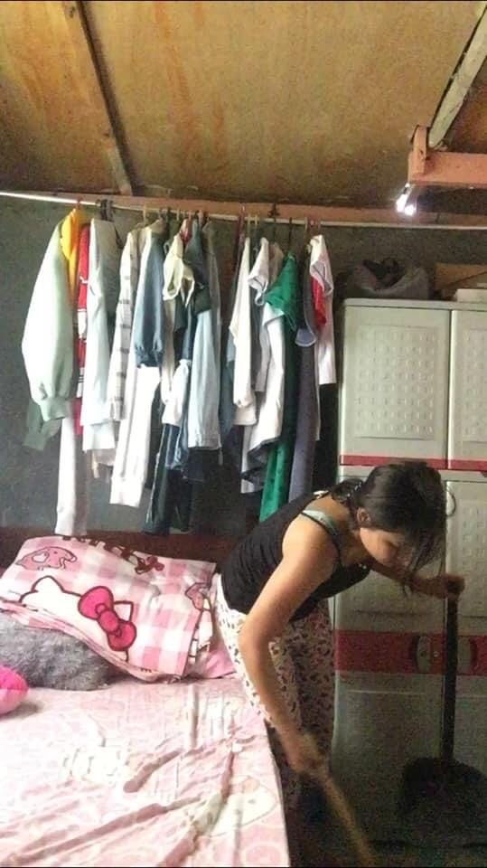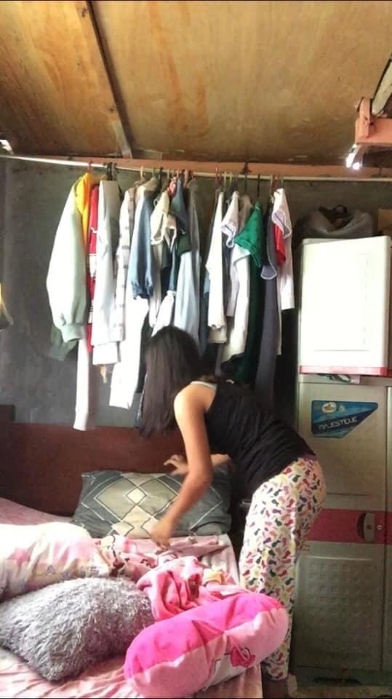

Cleaning Bedroom

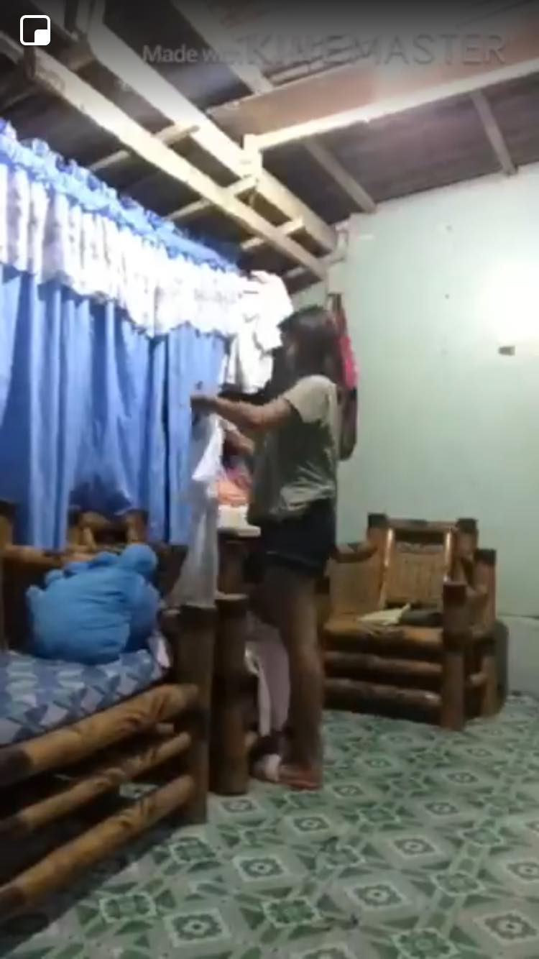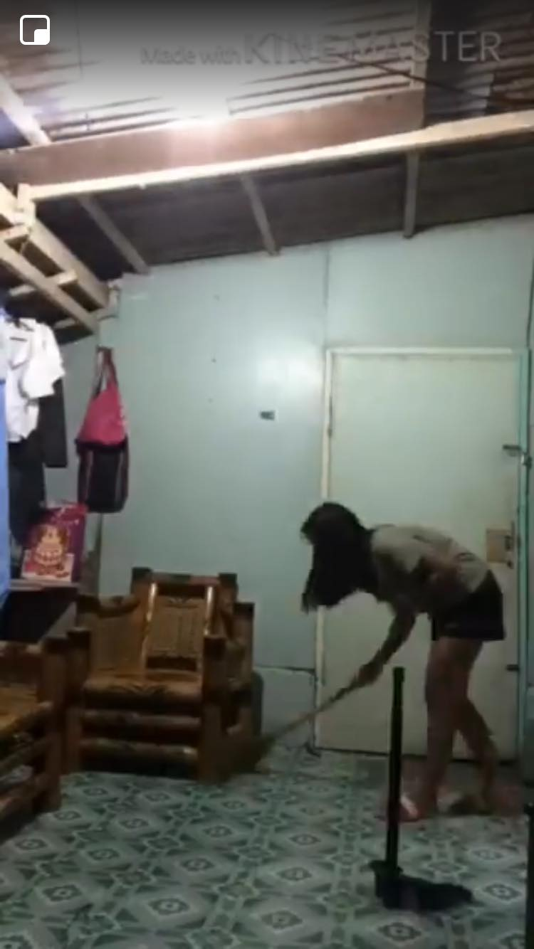

Cleaning Sala

1. **Reflection**

* Making such a simple task in our home. It has a big help for your family most especially with your parents because they are the one always doing that.
* Because it is very important because doing household chores is not that easy as you think. Like thinking about your only one parents doing that it is very hard which I am happy because I can help the and reduce their works while it quarantine.
* Easily get tired because I am not used to do some households just sometimes only but, for me its ok to be more flexible my body and to avoid bored.
* For me negative is to get easily get tired, but the rest of the task that I made is positive because it is not for only me it is always for my parents that I was able to help them while its was quarantine.